To work with SQL Server on Visual Studio

Step 1: Create New Project

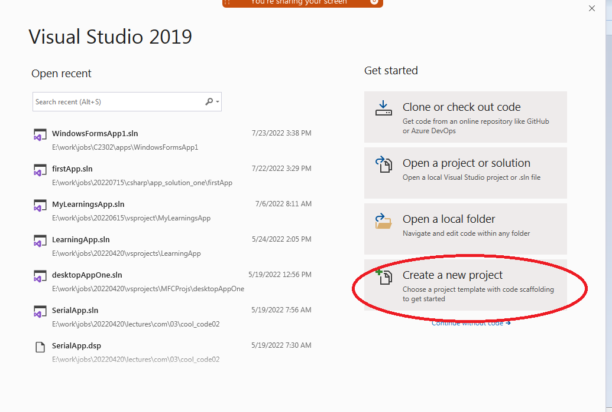

Step 2: Select the project type for working SQL Server inside the Visual Studio

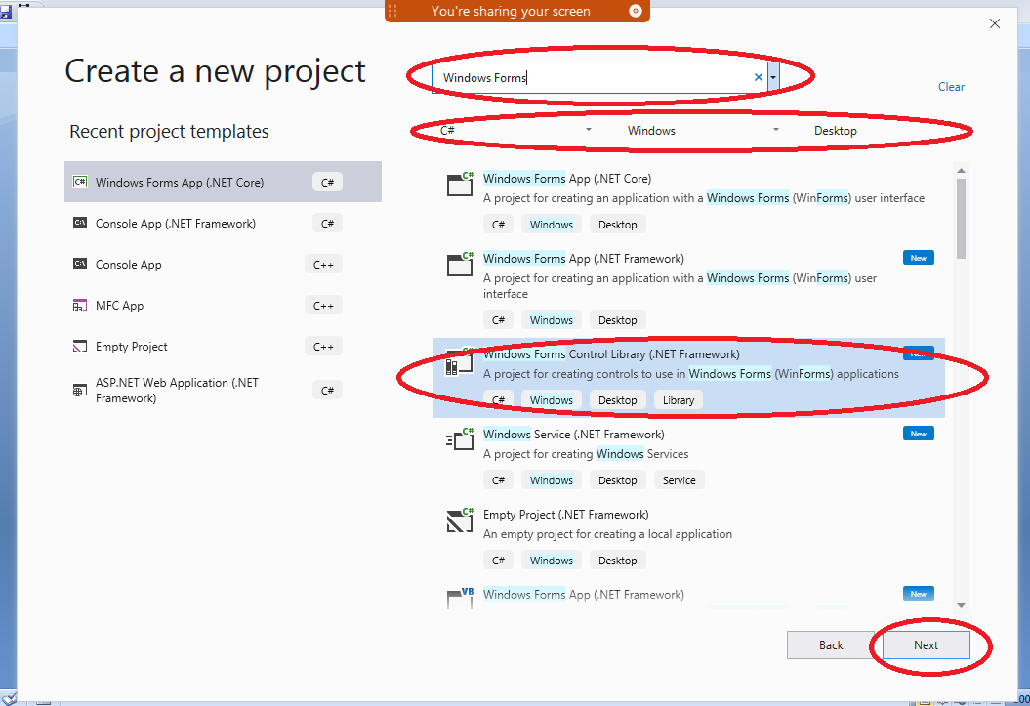

Step 3:

Provide Details for Winforms (Desktop) Application

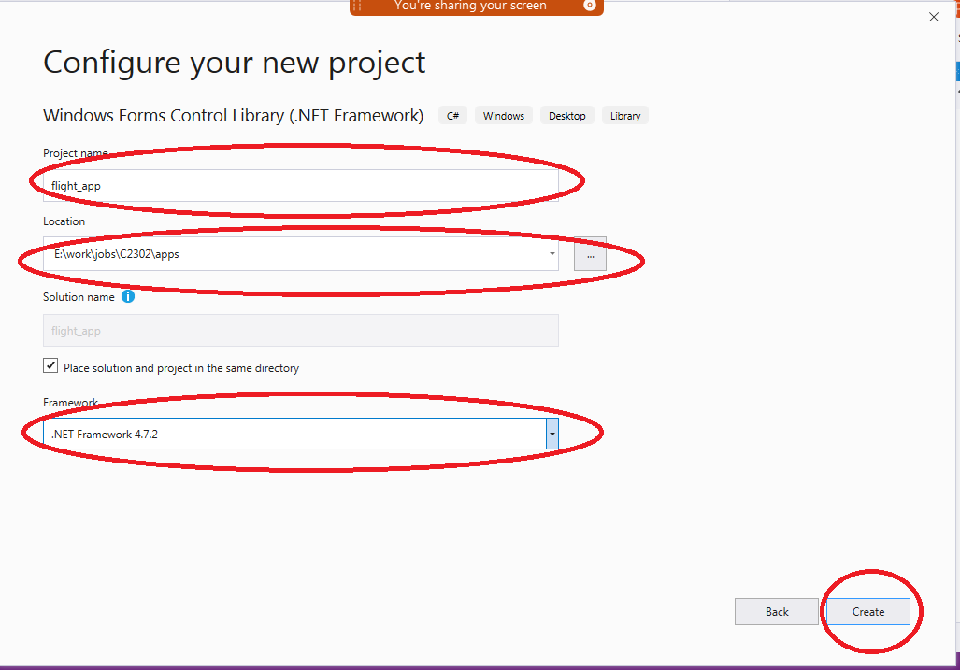

Step 3.1 : Points

To switch ON solution explorer and server explorer

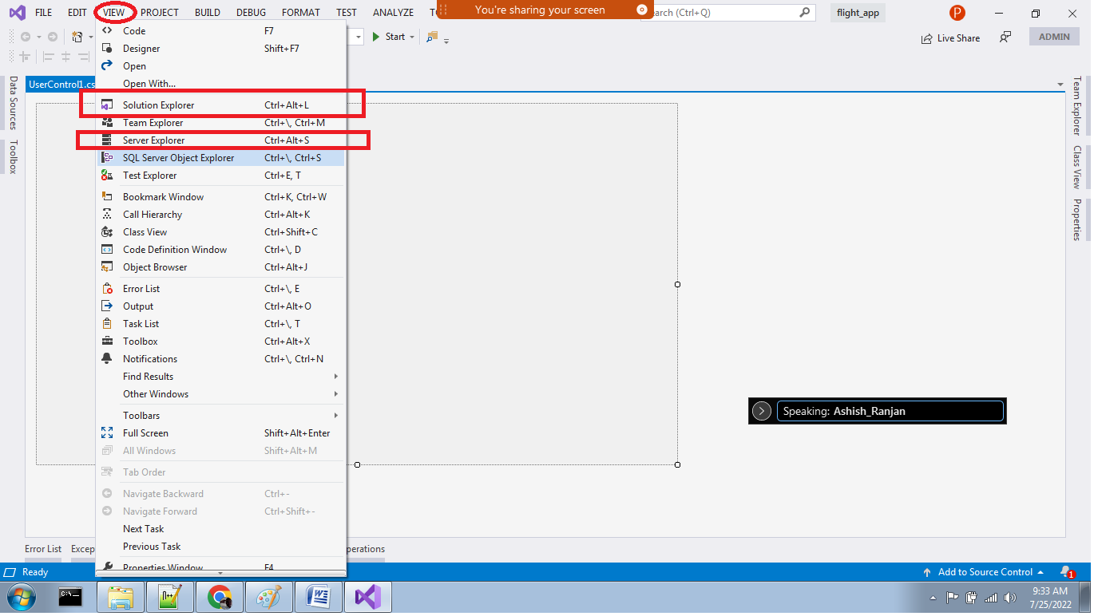

Step 3.2 Points

Right Click on Solution -> Add -> Solution related items

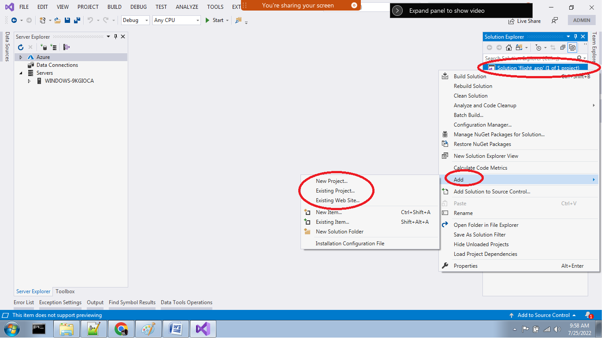

**Step 4:**

**Right Click on Project -> Add ->Project related items**

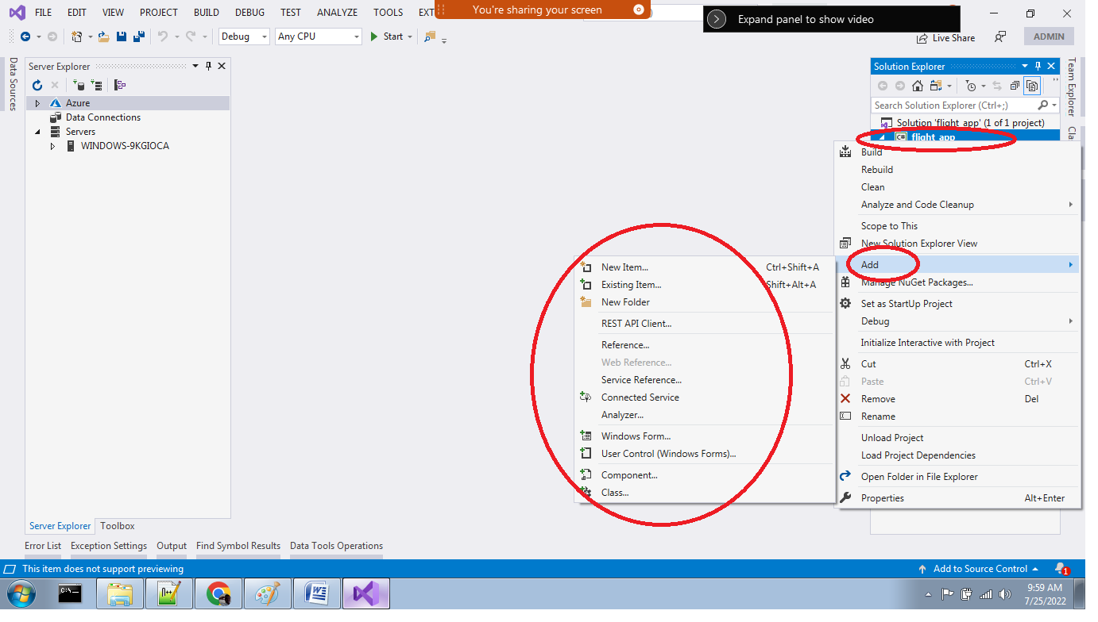

Step 5

Pick the item type : Under Category **Data -> Service based Database**

**Give** the **file name** for the database, for our case : flight_app_database.mdf

Then click **Add**

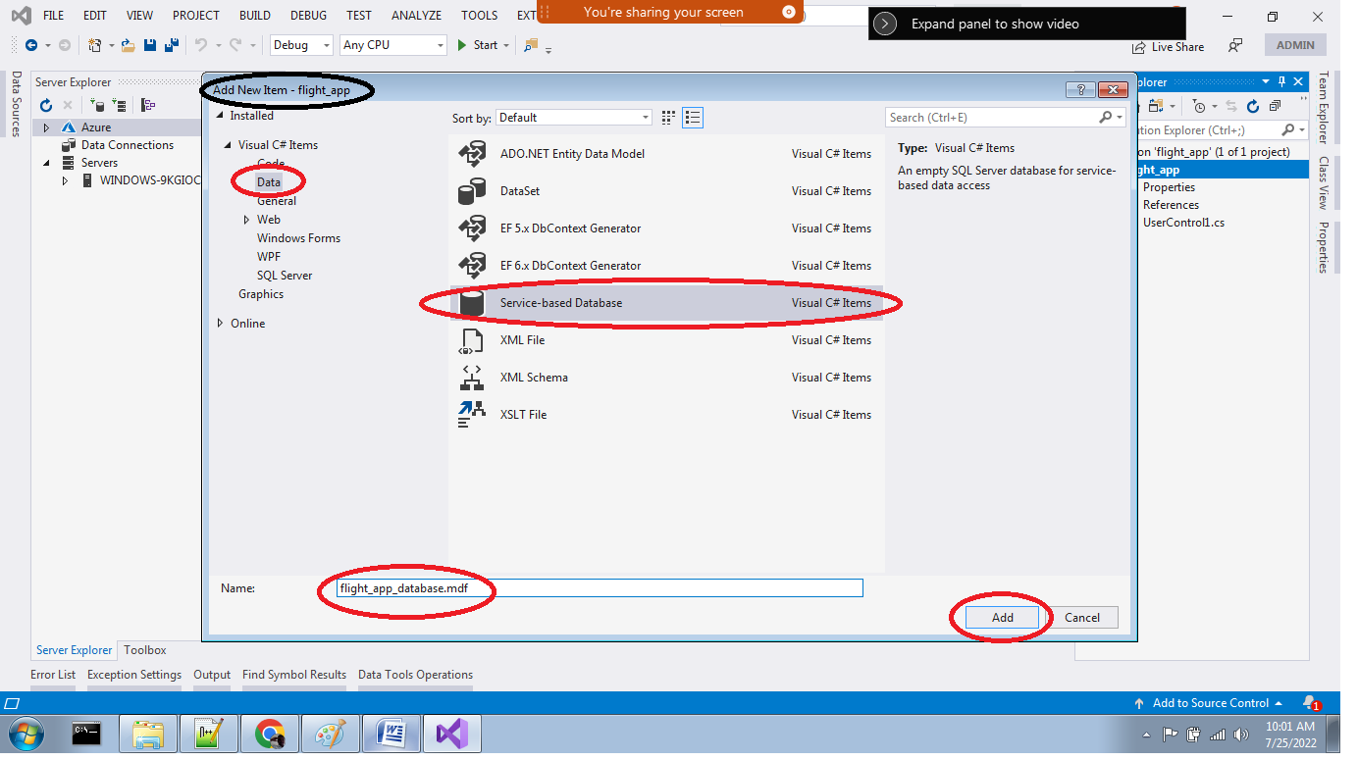

Now database is added into the project

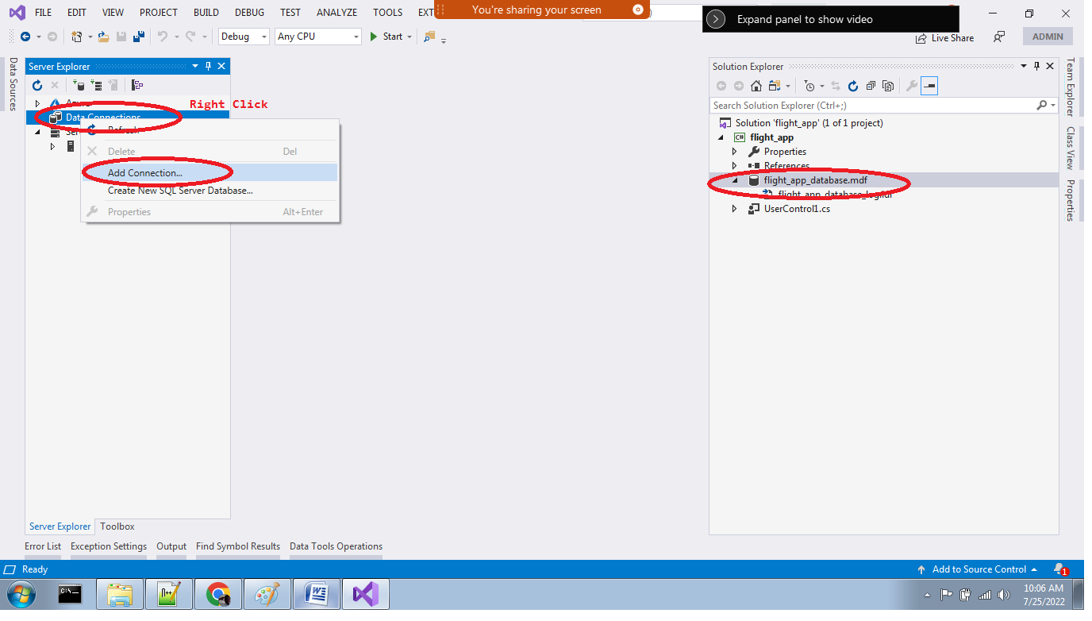

Select the database file “flight_app_database.mdf” in the solution explorer

See in the server explorer -> Data Connections -> The file has to be located

If file is not located, then use the above mentioned steps using the picture.

O Right Click in Server Explorer ->Data Connections

O Add Connections

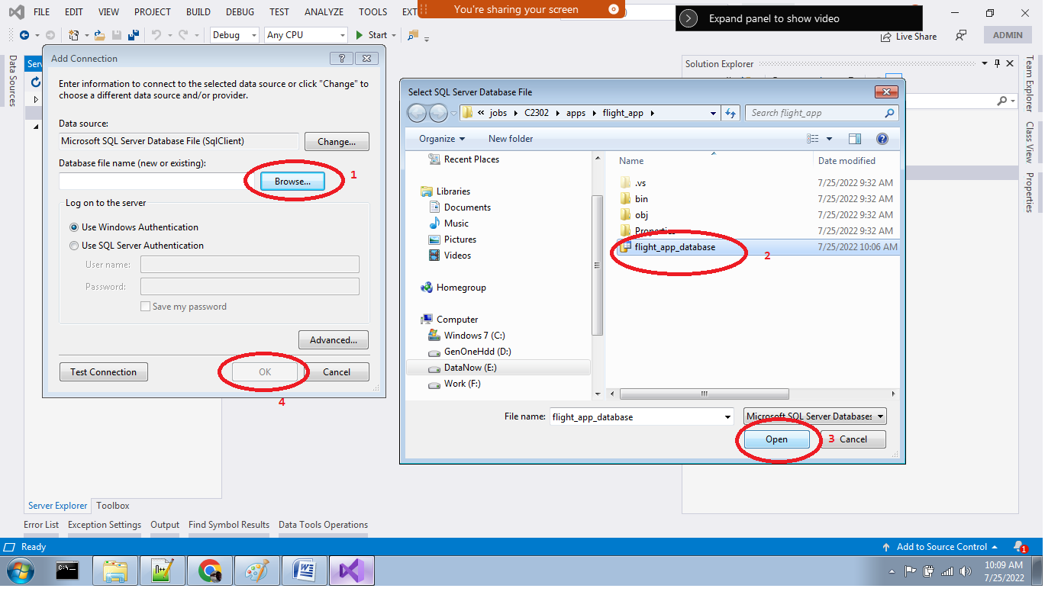

We will have “**Add Connections…**” dialogue box

Here we have to **browse** our database file “**flight_app_database.mdf**”

The click the command /button “**Open**”

Click “**OK**” from “Add Connections” dialogue.

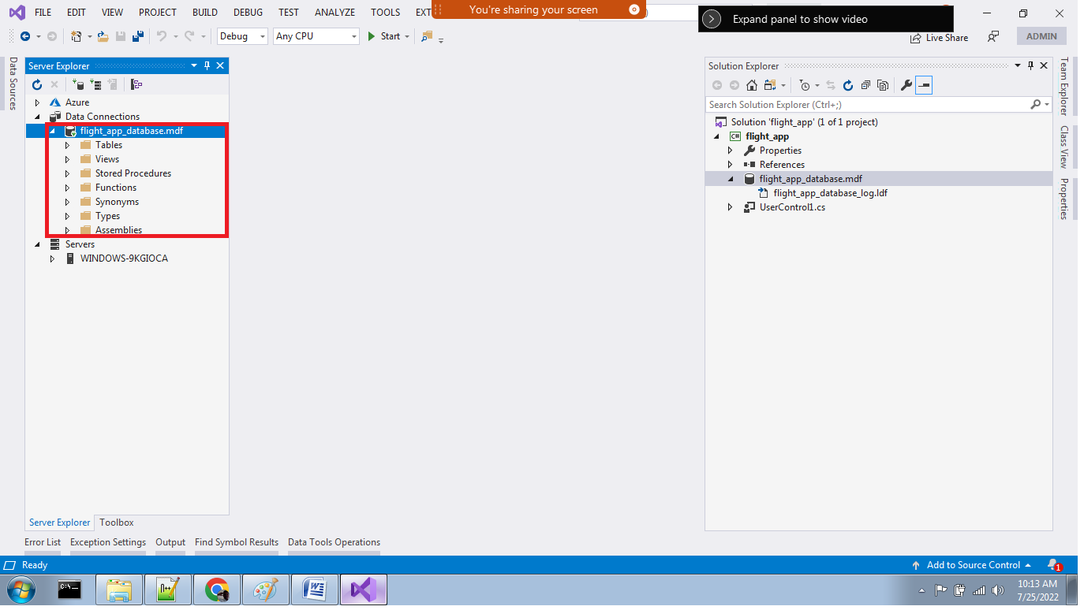

Now the **database** “flight_app_database.mdf” is added into **dataconnections** of the **server explorer**.

Once we **expand** the database we can see the inner objects category of the database

Now we can start to work with SQL Server inside the Visual Studio.

Now, we have to work with the Server Explorer->Data Connections->Selected Database

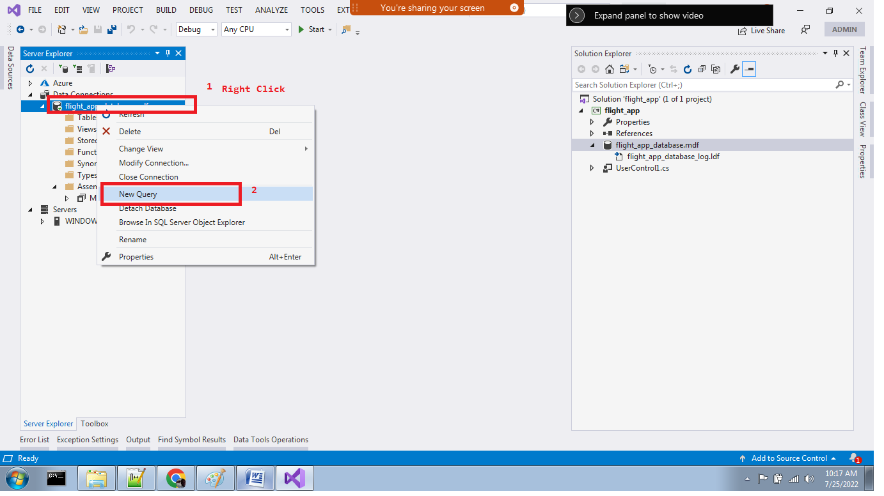

To open the query window: The above steps we have to follow.

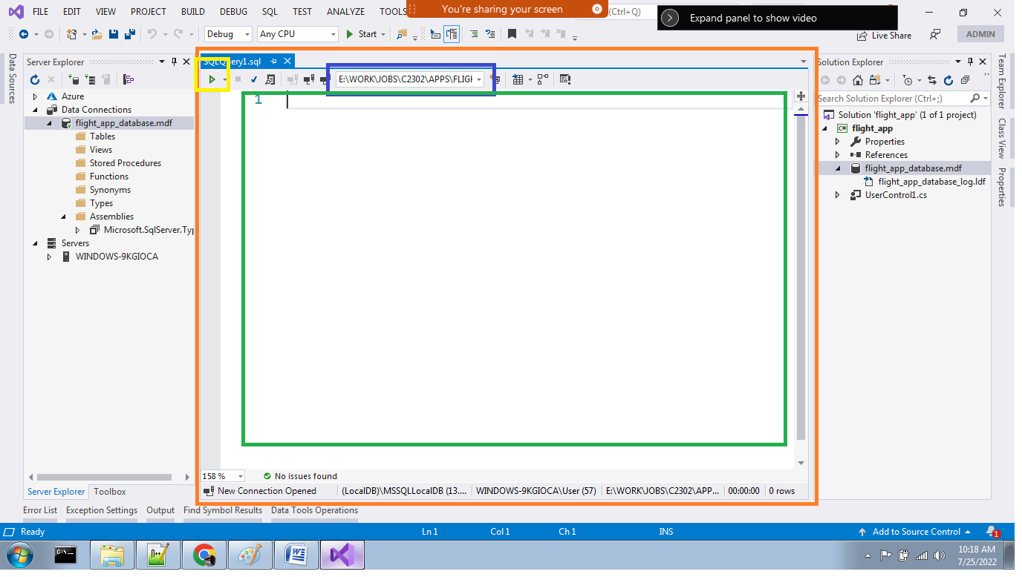

Now the query window is opened.

The **triangle icon** marked by **yellow border** is the **RUN option** to run our query

The **selected drop down option** marked by **blue border** is the selected database

**Green bordered area** is the place where **we write our T-SQL queries**/ statements/ stored procedures etc

How many winforms application I have to create for the case study “flight_ticket_booking”

One solution named “flight_app”

Inside solution, we have the project named “flight_app”

Only one solution to manage the entire case study.

Now how many database file we have to create for the case study “flight_ticket_booking”

Only one database file named **“flight_app_database.mdf”**

How many we can have inside the flight_app_database

One or more tables for our case study “flight_ticket_booking”

Some the tables we can create for the case study “flight_ticket_booking”

Some table names: **flight**, **customer**, **booking**